**Zero Downtime deployment steps**

# **TIBCO API Gateway Project Configuration: RoundRobin with Failover**

1. Create one Façade operation for an API (Project🡪 Routing 🡪 Façade Operations)

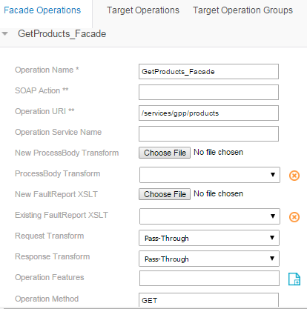

1. Create Target operations for the above Façade operation. (Project🡪 Routing 🡪 Target Operations)

Usually 2 Target operations per Façade operation is created, here to have zero downtime in deployment we are creating extra pair of Target operations. (i.e. 4 target operations for 4 AppNodes)

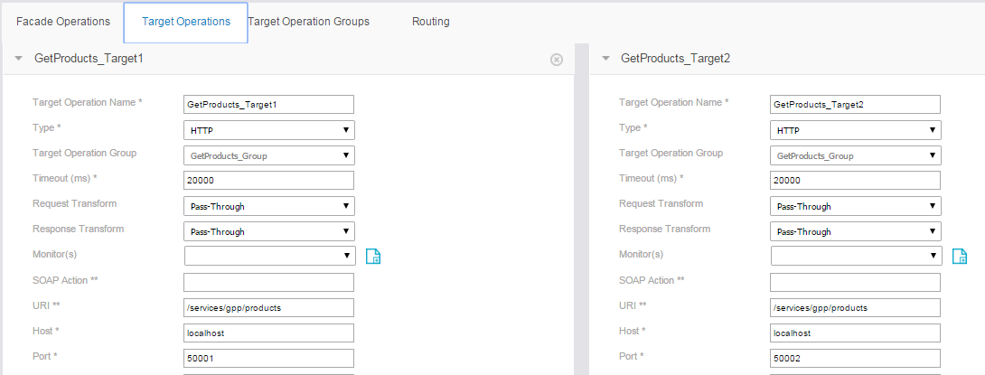

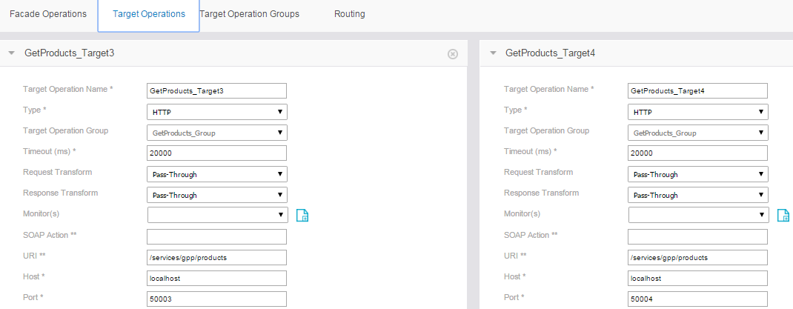

Note: For testing purpose we have replicated this in our local machine, whereas in DEV/QA/PROD there will be 2 machines (each appspace have 2 appnodes running on 2 separate machines .i.e., each application with same http port no. on 2 machines). So 2 port no. are sufficient for 4 target operations in DEV/QA/PROD.

1. Create Target Operation Groups with type = “**RoundRobin with Failover**”.

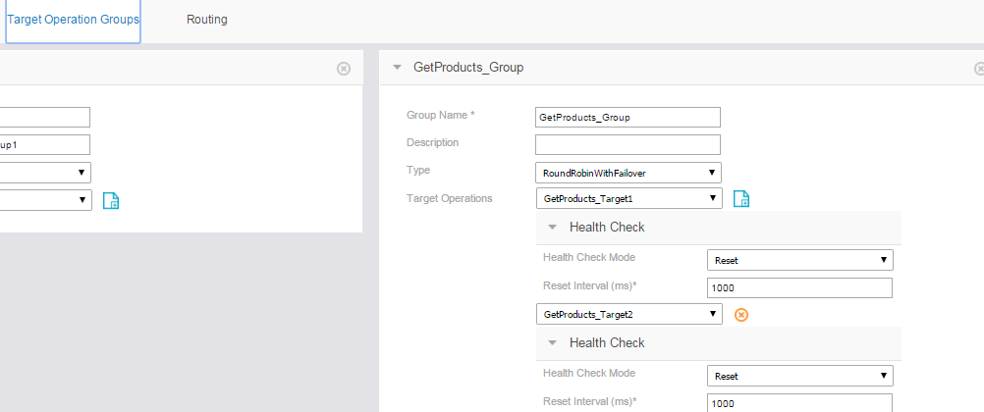

1. Deploy and start this project on asg-engine (asg-engine –a FSAPI)

# **TIBCO Admin/TEA configuration**

1. Create two appspaces.

create –d FSAPIDomain appspace FSAPIAppSpace1

create –d FSAPIDomain appspace FSAPIAppSpace2

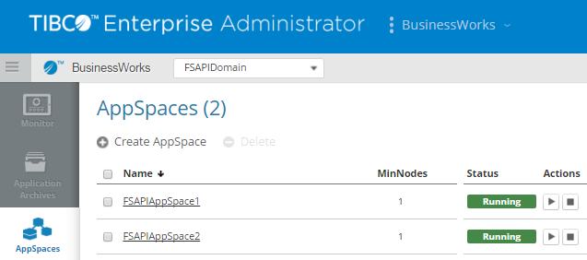

1. Create 2 appnodes for each appspace.

create -d FSAPIDomain -a FSAPIAppSpace1 -ag localhost -httpPort 25001 - osgiPort 25002 appnode FSAPIAppNode1

create -d FSAPIDomain -a FSAPIAppSpace1 -ag localhost -httpPort 25003 - osgiPort 25004 appnode FSAPIAppNode2

create -d FSAPIDomain -a FSAPIAppSpace2 -ag localhost -httpPort 25005 - osgiPort 25006 appnode FSAPIAppNode3

create -d FSAPIDomain -a FSAPIAppSpace2 -ag localhost -httpPort 25007 - osgiPort 25008 appnode FSAPIAppNode4

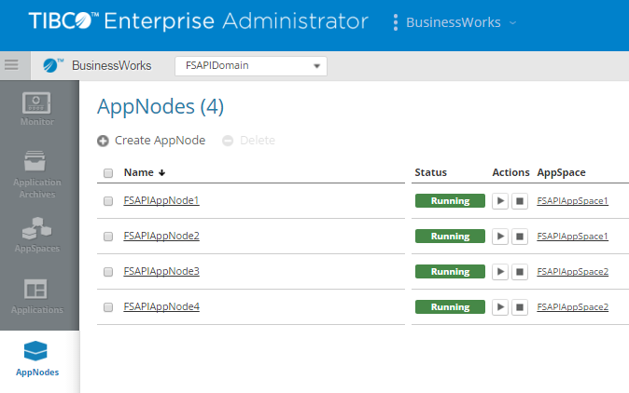

1. Deploy Application on FSAPIAppSpace1.

deploy -d FSAPIDomain -a FSAPIAppSpace1 FSAPI_v1_1.0.0.ear



1. Configure Application with substvar file for each appnode pointing to different http ports 50001 & 50002.

config -d FSAPIDomain -a FSAPIAppSpace1 -n FSAPIAppNode1 -pf C:/Users/494001/Desktop/Artifacts/FSAPI_AppNode1_v1.substvar application FSAPI_v1 1.0

config -d FSAPIDomain -a FSAPIAppSpace1 -n FSAPIAppNode2 -pf C:/Users/494001/Desktop/Artifacts/FSAPI_AppNode2_v1.substvar application FSAPI_v1 1.0

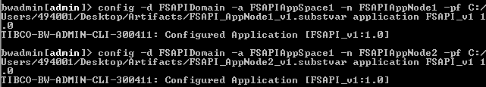

1. Start the application.



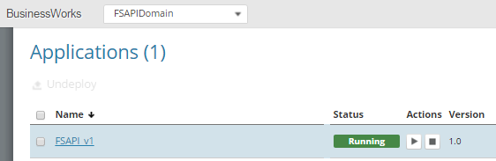

1. Now application is running on 2 AppNodes (application pointed to http ports 50001 & 50002)

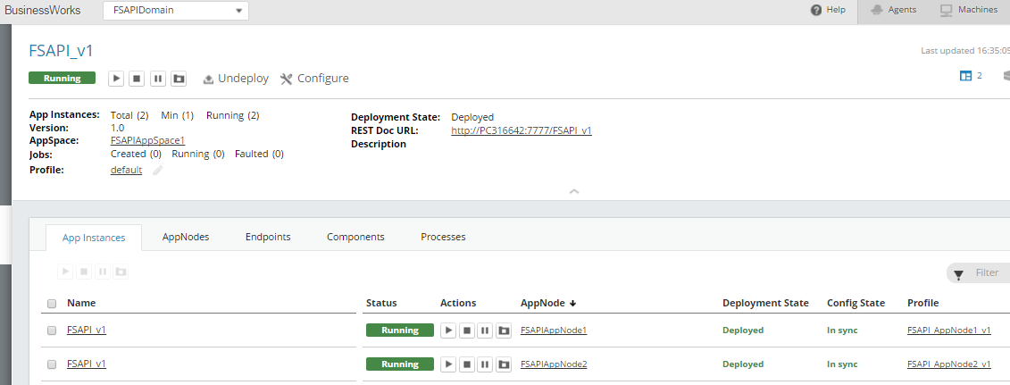

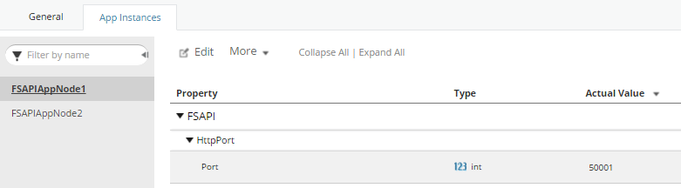

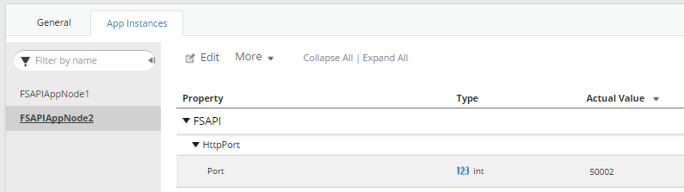

1. With this set up all requests will be hitting 2 AppNodes in Round Robin manner

Request has hit: Domain : FSAPIDomain AppSpace : FSAPIAppSpace1 AppNode : FSAPIAppNode1

Request has hit: Domain : FSAPIDomain AppSpace : FSAPIAppSpace1 AppNode : FSAPIAppNode2

1. Now if we have to do hot deployment of a BW code , we can deploy new .ear file on 2nd AppSpace where there are 2 more AppNodes

deploy -d FSAPIDomain -a FSAPIAppSpace2 FSAPI_v2_1.0.0.ear



1. Configure Application with substvar file for each appnode pointing to different http ports 50003 & 50004.

config -d FSAPIDomain -a FSAPIAppSpace2 -n FSAPIAppNode1 -pf C:/Users/494001/Desktop/Artifacts/FSAPI_AppNode1_v2.substvar application FSAPI_v2 1.0

config -d FSAPIDomain -a FSAPIAppSpace2 -n FSAPIAppNode2 -pf C:/Users/494001/Desktop/Artifacts/FSAPI_AppNode2_v2.substvar application FSAPI_v2 1.0

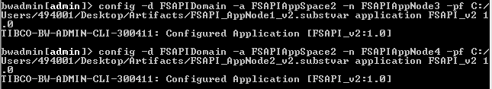

1. Start the new application

start -d FSAPIDomain -a FSAPIAppSpace2 application FSAPI_v2 1.0



1. Now the requests will hit in the following RoundRobin manner

Domain: FSAPIDomain AppSpace: FSAPIAppSpace1 AppNode: FSAPIAppNode1

Domain: FSAPIDomain AppSpace: FSAPIAppSpace1 AppNode: FSAPIAppNode2

Domain: FSAPIDomain AppSpace: FSAPIAppSpace2 AppNode: FSAPIAppNode3

Domain: FSAPIDomain AppSpace: FSAPIAppSpace2 AppNode: FSAPIAppNode4

Domain: FSAPIDomain AppSpace: FSAPIAppSpace1 AppNode: FSAPIAppNode1

Domain: FSAPIDomain AppSpace: FSAPIAppSpace1 AppNode: FSAPIAppNode2

Domain: FSAPIDomain AppSpace: FSAPIAppSpace2 AppNode: FSAPIAppNode3

Domain: FSAPIDomain AppSpace: FSAPIAppSpace2 AppNode: FSAPIAppNode4

1. Now old Application (FSAPI_v1) on AppSpace1 can be stopped so that all new request will now be hitting newly deployed FSAPI_v2 in below RoundRobin manner.

Domain: FSAPIDomain AppSpace: FSAPIAppSpace2 AppNode: FSAPIAppNode3

Domain: FSAPIDomain AppSpace: FSAPIAppSpace2 AppNode: FSAPIAppNode4

Domain: FSAPIDomain AppSpace: FSAPIAppSpace2 AppNode: FSAPIAppNode3

Domain: FSAPIDomain AppSpace: FSAPIAppSpace2 AppNode: FSAPIAppNode4